**Full and Partial selectors:**

**Full selector:**

Full selector contains all the nodes starting from the aplication to the final node selected.

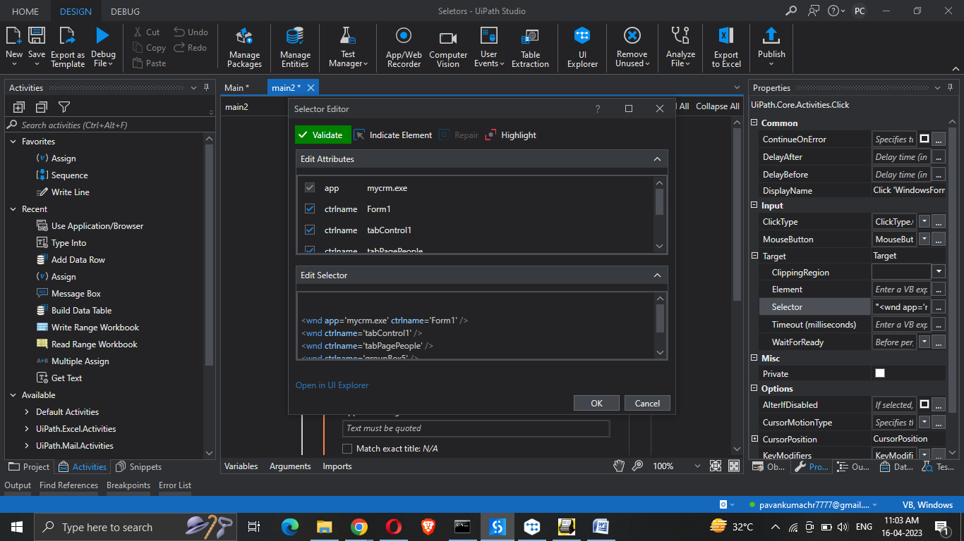

* This contails information and activities of all nodes
* This is very good to user while we are switching between appications.

**Partial selector:**

Partial selector inheriting the properties from the top main application node(grey color – application node) and rest will be taken from the inner container node.

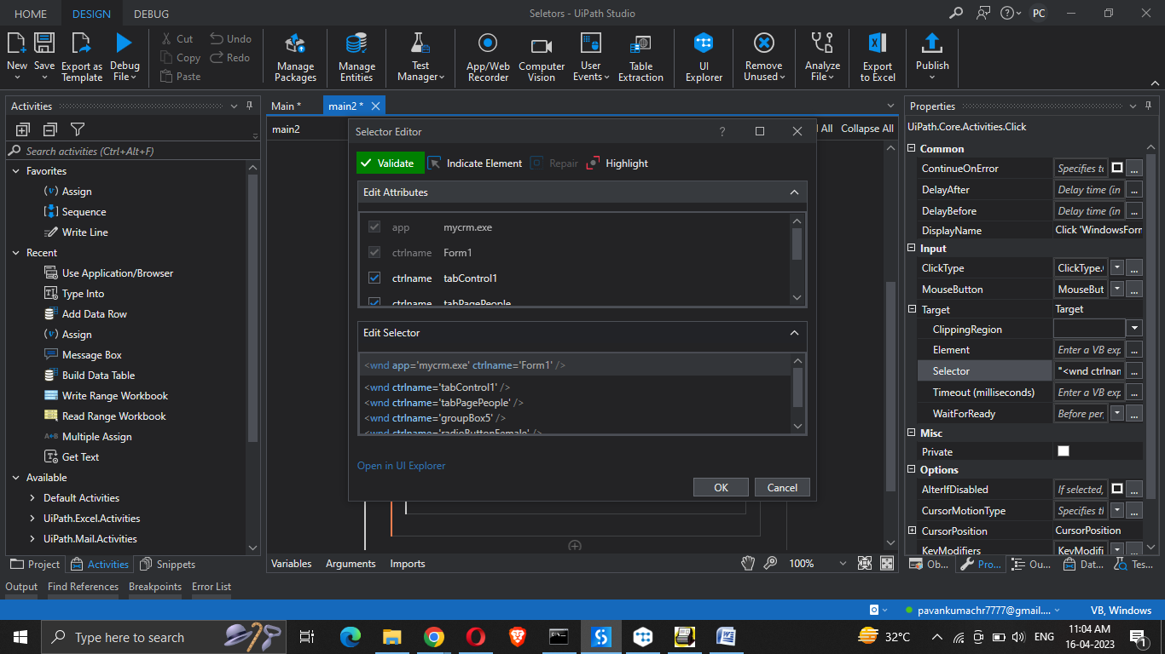

* Main appication node (like form1 is grey in color)
* Rest of the nodes inherit from that main app node
* If we are just entering the data into an already existing fields or application we can go with partial selector(we can go woth full selector also but with with partial selector it is the best practice)(while using only one application)

**Recording option:**

Even recording also can go with full and partial selector concepts

* Basic recording goes with full selector.
* Desktop recording goes with partial selector.